**3D BIFURCATING ARTERY (STEADY)**

**ANSYS ANALYSIS**

**By, ANANTHAN A**

**ACKNOWLEDGEMENT:**

This Simulation is made under great help and support from Ansys Academy and Dr. Rajash Bhaskaran, Cornell University.

**PROBLEM SPECIFICATION**

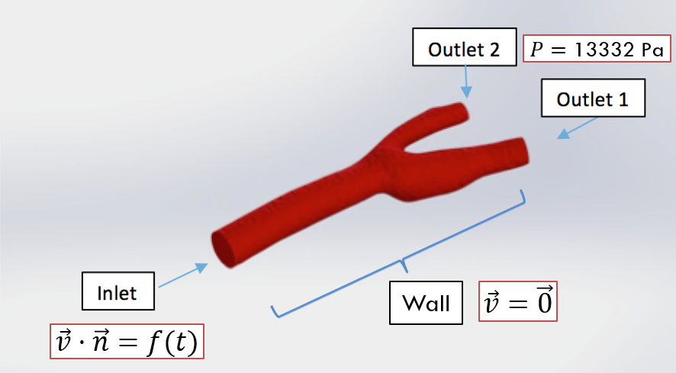

Blood flows through the bifurcating artery from the inlet (to the left in the graph above) and exits from the two outlets (to the right). The diameter of the artery at the inlet is around 6.3 mm. The diameter of Outlet 1 is around 4.5 mm and the diameter of Outlet 2 is around 3.0 mm. The density of blood is 1060 kg/m^3. Blood is a non-Newtonian fluid, meaning the coefficient of viscosity of blood is not a constant, but is a function of velocity gradients. Because velocity gradients have approximately a 10% effect on the results, for simplicity model the fluid with a constant viscosity here. Ignore the pulsatile and cyclic nature of blood flow, as the problem would become transient. The pressure at the outlet is defined to be constant (100 mm Hg).

* Introduce bifurcating artery problem
* Geometry: carotid artery from Grab CAD
* Inlet: 0.315 m/s, outlets: 13332 Pa, no-slip walls
* Real velocity is pulsatile, this is approximation
* ρ =1060 kg/m3, µ = 0.0035 Pa s (based on blood)
* Approximate as Newtonian fluid for simplicity
* Reynolds number of 600 (based on inlet diameter)
* Engineering background

**PRE-ANALYSIS**

**GOVERNING EQUATIONS**

Before starting a CFD simulation, it is always good to take a look at the governing equations underlying the physics. In this case, although we have additional complexities such as pulsatile flow and non-Newtonian fluids, the governing equations are the same as any other fluids problem. The most fundamental governing equations are the continuity equation and the Navier-Stokes equations. Here, let's have a quick review of the equations.  
Continuity Equation:

https://courses.ansys.com/wp-content/uploads/2020/05/continuity_eq.png

However, as blood can be regarded as an incompressible fluid, the rate of density change is zero, thus the continuity equation above can be further simplified in the form below:

https://courses.ansys.com/wp-content/uploads/2020/05/continuity_incompressible.png

The Navier-Stokes Equation:

https://courses.ansys.com/wp-content/uploads/2020/05/NS-eqn.png

One thing to notice in the Navier-Stokes equation is that the viscosity coefficient of μ is not a constant but rather a function of shear rate. Blood gets less viscous as the shear rate increases (shear thinning). Here, we model the blood viscosity using the Carreau fluids model. The mathematical formulation of the Carreau model is as follows:

https://courses.ansys.com/wp-content/uploads/2020/05/blood-model-eqn.png

In the equations above, μeff is the effective viscosity. μ0, μinf, λ, and n are material coefficients.

For the case of blood [2],

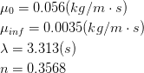

**BOUNDARY CONDITIONS**

**Wall:**

The easiest boundary condition to determine is the artery wall. We simply need to define the wall regions of this model and set it to “wall”. From a physical viewpoint, the “wall” condition dictates that the velocity at the wall is zero.

**Inlet:**

As we know, mammalian blood flow is pulsatile and cyclic in nature. Thus the velocity at the inlet is not set to be a constant, but instead, in this case, it is a time-varying periodic profile. The pulsatile profile within each period is considered to be a combination of two phases. During the systolic phase, the velocity at the inlet varies in a sinusoidal pattern. The sine wave during the systolic phase has a peak velocity of 0.5 m/s and a minimum velocity of 0.1 m/s. Assuming a heartbeat rate of 120 per minute, the duration of each period is 0.5 s. This model for pulsatile blood flow is proposed by Sinnott et, al. [3].

To describe the profile more clearly, a mathematical description is also given below:

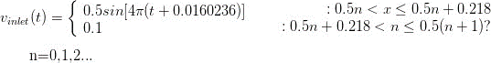

**Outlets:**

The systolic pressure of a healthy human is around 120 mm Hg and the diastolic pressure of a healthy human is around 80 mm Hg. Thus, taking the average pressure of the two phases, we use 100 mm Hg (around 13332 Pascal) as the static gauge pressure at the outlets.

**GEOMETRY**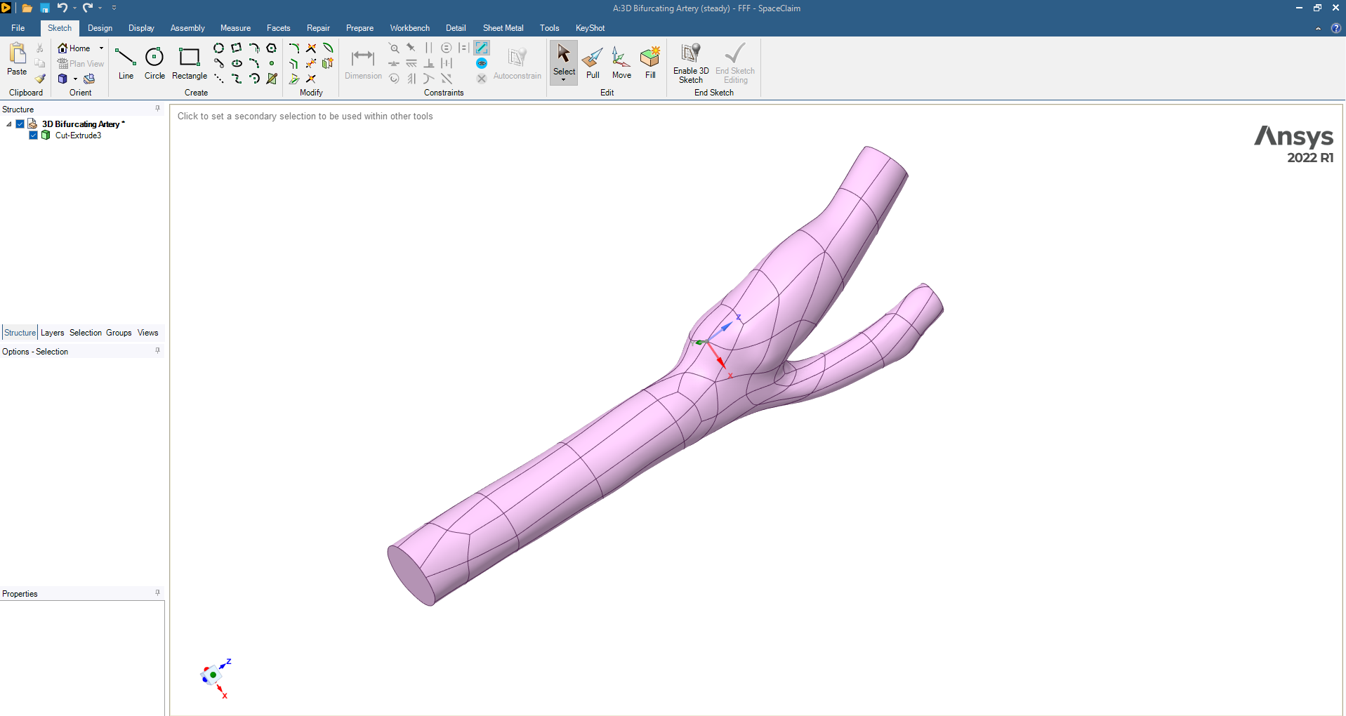

**Carotid artery**

• Inlet ~ diameter of 6.3mm

• Outlets ~ 4.5 and 3mm (larger and smaller respectively)

• Ratio of areas (external/internal): 14.826mm2/7.2214mm2 ~ 2

• Common carotid artery: 30.977mm^2

• External/common = 50% (vs 50% in book)

• Internal/common = 32% (vs 25% in book

**MESH**

* Mesh > Details > Defaults > Element Size > 1.0 mm
* Insert > Body Sizing > Element Size > 1.0 mm
* Right-click on Coordinate Systems > Insert > Coordinate System
* Change to Body Selection Filter and choose the artery
* Insert > Body Sizing > Sphere of Influence
* Sphere Center: Coordinate System (what we just created)
* Sphere Radius: 12.0 mm
* Element Size: 0.5 mm (to capture effects near bifurcation)
* Insert > Inflation
* Scope > Geometry: apply to entire body
* Definition > Boundary: all 122 faces
* ▪ Face Selection Filter, right-click, Select All
* Inflation Option: Total Thickness
* Number of Layers: 5
* Maximum Thickness: 0.6 mm
* Named Selections
* Inlet, outlet1 (larger), outlet2 (smaller), wall_artery, fluid_zone (the body)

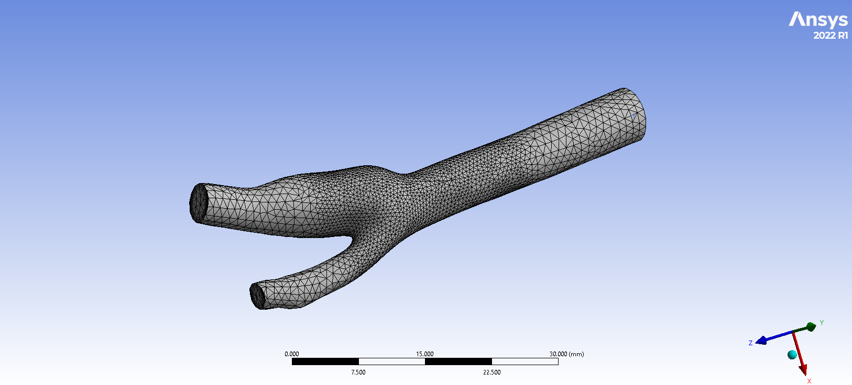

**EXPECTED RESULTS/TRENDS**

* 70% of flow exits through larger outlet
* Images from textbook for carotid artery “Transport Phenomena in Biological Systems” by Truskey, Yuan and Katz.
* Calculate expected maximum velocity and wall shear

**RESULTS**

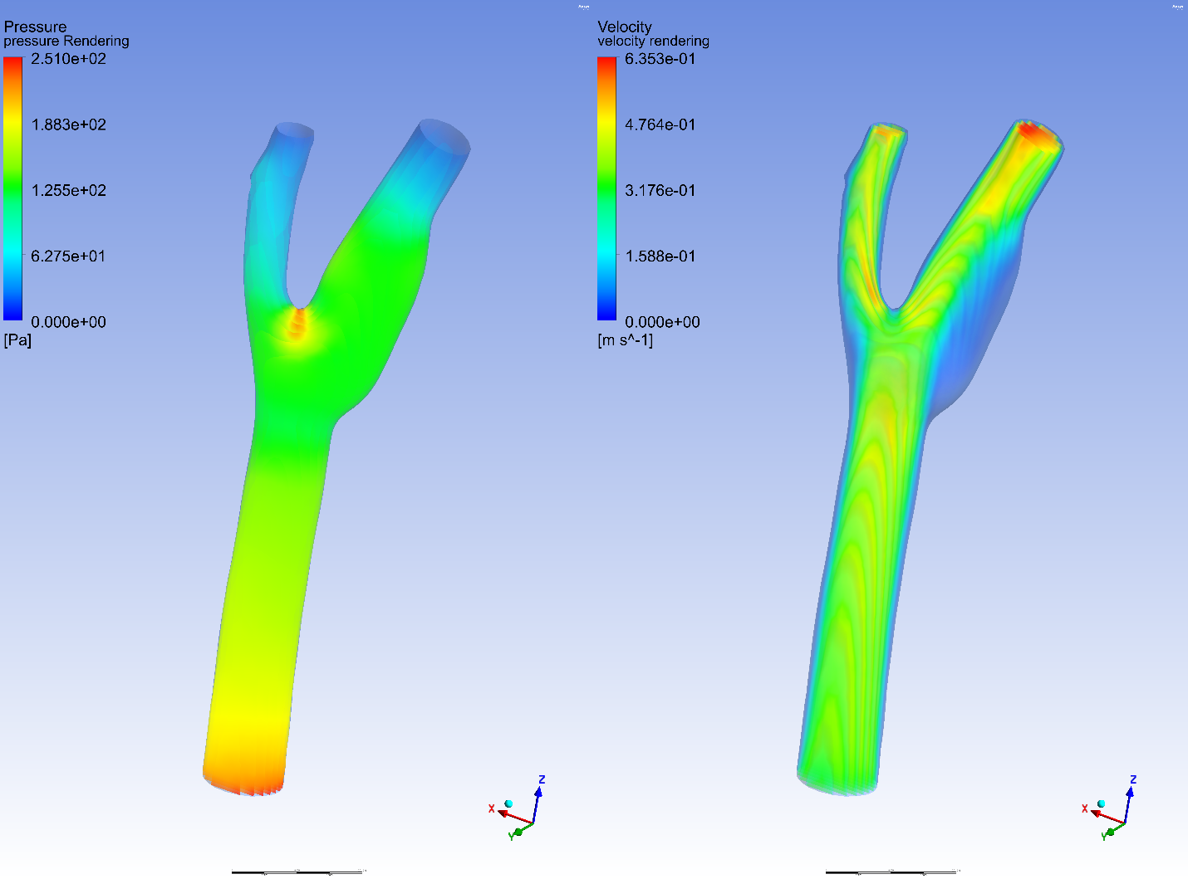

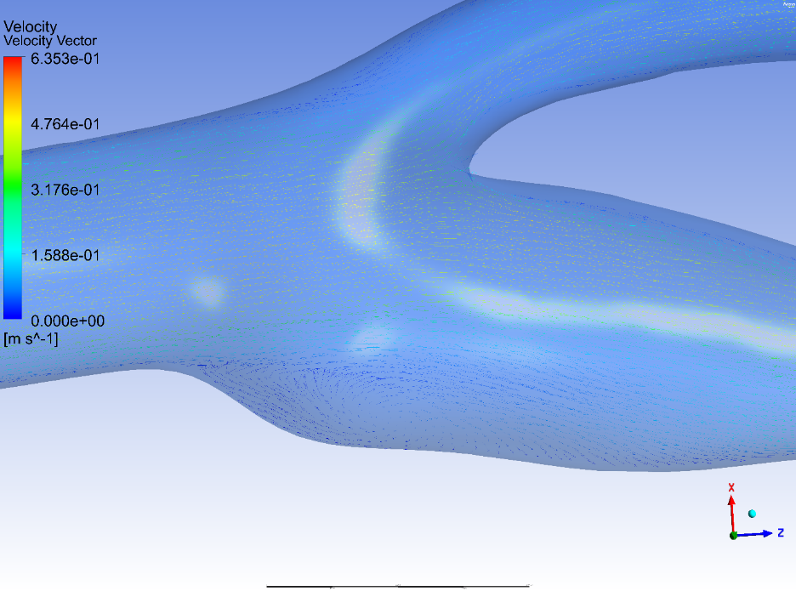

**VERIFICATION**

The first two things we check for verification are the mass conservation and inlet boundary conditions. We check the inlet boundary conditions to ensure that the conditions are as we expect. Then, we do a mesh refinement and use a smaller time-step to check whether the results are consistent with the original calculation. By using a finer mesh and a smaller time-step, we investigate the effects of truncation error caused by spatial discretization and temporal discretization. Then we will do a case comparison for the results obtained after spatial and temporal refinement.

**MASS CONSERVATION**

To check whether mass is conserved in this calculation, go back into Fluent and go to Reports → Fluxes and then under options, check "Mass flow rate." Then select the one inlet and two outlets. We would expect the mass flux to sum up to zero (or extremely small).

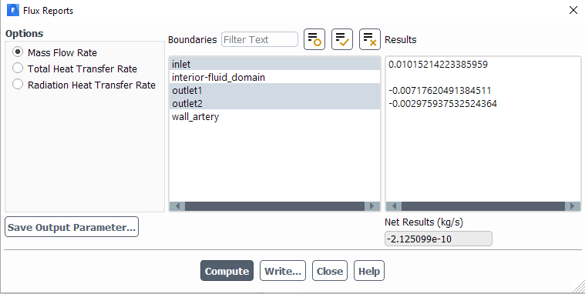

As we can see from the window above, the mass fluxes add up to -2.125e-10, which is very close to zero. Thus, we can conclude that mass is conserved in the simulation.

**VALIDATION**

It is also always good to compare the results obtained from simulations with experimental results. In this case, however, we do not have experimental data, but we do have a description of flow in the carotid artery, courtesy of your textbook. We find that the flow in the internal and external carotid arteries should be approximately 70% and 30% of the total flow in the common carotid artery. We can check this in Fluent by using the mass flow rate values we found earlier.

**REFERENCES:**

1. Cutnell, John & Johnson, Kenneth. Physics, Fourth Edition. Wiley, 1998: 308.
2. Siebert, Mark W. & Fodor, Petru S. Newtonian and Non-Newtonian Blood Flow over a Backward- Facing Step – A Case Study. Excerpt from the Proceedings of the COMSOL Conference 2009 Boston 2009.
3. SINNOTT, Matthew. CLEARY, Paul W. & PRAKASH, Mahesh. An investigation of pulsatile blood flow in a bifurcating artery using a grid-free method. Fifth International Conference on CFD in the Process Industries CSIRO, Melbourne, Australia 2006
4. "Transport Phenomena in Biological Systems" by Truskey, Yuan, and Katz.